The Quadruple Test
  - 2021

Specialization/Target

Value Proposition

Presence

Prospection

Specialization/Target
Specialization
The first step in real estate practice after basic commercial training is to choose a specialty.
How to Choose It? Very simple let's answer the following three questions:
What do we like?
________________________________________________________________
What Skills Do We Have?
________________________________________________________________
What is Inventory Rotation?
________________________________________________________________
We must specify which discipline we like best: offices, commercial, industrial, multifamily, hospitality, special purpose, etc.
What skills we have, financial, trading, market knowledge, etc.
From what we like and have the qualifications for practice, we need to check how many transactions a year are made in our market.

Target:
The Target should be defined in detail, for example, suppose we have chosen Industrial, Sizes between 5,000 and 20,000 sqft, for sale and for rent.
Chances are we have three main targets as follows:
Seller/Landlord
Buyer/Tenant Rep
Investors (Investment Sales)
Each target must be clearly defined, such as for Investors in an Industrial Niche:
Man
Legal Representative of The Firm
Between 45-60 years
Postgraduate Studies
Financially Sophisticated
Looking for Capitalization Rates equal to or above the market average
Preferably in multi units of 5,000 sqft, buildings totaling 50,000 m2.
Access to Commercial Financing

Value Proposition
What is our value proposition, what makes us different from our competitors? What do we bring to the table for our customers?
- It is important to carry out an analysis of the competition, based on the specialty chosen in 1. For example, if there is a firm/broker that is only dedicated to Industrial and you are chosen Retail, you would not need to analyze that competition.

- Perform a SWOT analysis (Strengths, Weaknesses, Opportunities, and Threats)
These two activities will help us lay the foundation for preparing our Value Proposition, as follows:
Why would a Prospect take your call? Why would they meet you, and be willing to hire you?
When we develop our Value Proposition, we will begin by pointing out our personal attributes.
Value Proposition is the most important tool to attract the Prospectus.
What are your most important attributes?
What are the most important attributes your company gives you?
What benefit do you bring to your client to put the project in your hands with peace of mind and without worries?
Check by presenting a specific example where these skills were demonstrated and helped your customer significantly.

Presence
We must establish a presence as an authority in our markets, it should be noted that presence is not the same as prospecting, the presence is marketing of our image. The Presence consists of three activities: Personal Presence, Physical Presence and Digital Presence. To succeed as an influencer in the market we must combine the three activities, orchestrated in a uniform and coherent way.
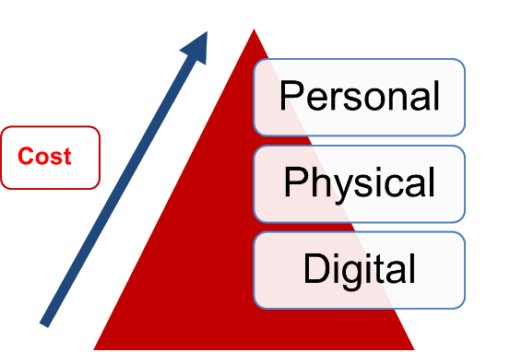
As can be seen in the graph, the cost of activities goes crescendo from the base of the pyramid to the vertex. In other words, the most expensive activity is La Personal, as you would expect since it is our time that we are investing.
Personal Presence:
Personal Presence is the most expensive, but at the same time it is the most effective and consists of holding meetings one by one, and as a group. It is recommended to hold at least 5 meetings one to one weekly and at least one group meeting quarterly. My recommendation is to divide the 5, into three cafes, a meal and a drink.
Physical Presence:
As the name implies, it is a physically palpable presence, such as a "White Paper", a printed "Newsletter", offering of the company's services, proposition of value, market conditions, success studies, print advertising, sponsorships at events.
Digital Presence:
The Digital Presence consists of all activities related to the Internet and Email. In email: "Digital Newsletter", market information, news of interest, recently closed businesses, new urban and infrastructure developments, etc. On "Social Media" LinkedIn, Facebook, Blogs, etc.

Extracted from The Massimo Group Coaching Program

It should be noted that these three activities must maintain the same image, causing confusion for example if the linkedin profile is different from the profile used on Facebook. The "Brand" or image must be consistent so that it has a multiplier effect.

Prospection
Prospecting is the heart in the practice of commercial real estate, it is the firewood that is needed to keep the bonfire lit. Prospecting by far to Presence, it's sales, that's when we order for the business. Prospecting should be carried out in a systematic manner by attacking the selected target to which the value proposition will be presented.
A daily prospecting of at least two (2) hours is recommended, in which we cannot be disturbed with any interruption. Prospecting calls should be prepared with prior references of material of interest sent and/or based on known contacts.
The Quadruple Test will guarantee us success in the practice of commercial real estate as long as we do it by the book. If you are interested in continuing with THE JM TEAM Training, Coaching and Networking programs, please visit us at:
thejmteam.net

